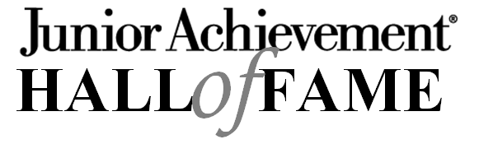

Junior Achievement Hall of Fame honors those who serve our community in the business, educational, philanthropic, religious, social service, arts or science professional arenas. Nominees must be business, community and/or civic leaders who, through their actions and accomplishments, have enhanced the business and economic environment of the Great Lakes Bay Region. The recipient is honored for their tremendous contributions to the quality of life and the business climate in the area.

They will have demonstrated the following within their respective arena:

- Business Excellence: Honorees, from the public, educational, non-profit or private sector, are held as outstanding examples of the business world within their respective environment.

- Entrepreneurial Spirit, Courageous Thinking and Action: Honorees demonstrate entrepreneurial spirit and outstanding management skills by founding or leading an accomplished business with vision, innovation and integrity.

- Inspiring Leadership: Honorees demonstrate an extraordinary ability to influence people
and events. They have achieved a high level of respect within the business and public communities.

- Community Impact: Honorees apply leadership skills to the community through public service, philanthropy and community involvement. They utilize the free enterprise system to improve the quality of the lives of others.

- Role Model: Honorees demonstrate exemplary conduct and serve as inspirational role models for others,
especially youth.
Award Descriptions
Laureate: May or may not be currently holding the position in which they achieved the major success or for which they are being honored. However, if the Laureate is currently holding the position, he/she should be at the peak of their career.

Rising Star: Midland Area Only. Must under 50, and while may have made a significant impact already, are considered to still be building their business or career.

Education Achievement Award: This award is reserved for our educators that have made significant contributions to youth in area schools specifically involving Junior Achievement.

IMPORTANT DATES

Midland Area: Nomination Deadline June 30, 2023

Hall of Fame Event October 2023 at The H Hotel

Saginaw & Bay Area: Nomination Deadline December 31, 2022

Hall of Fame Event Thursday, April 27, 2023 at Horizons

For more information: www.janorthcentralmi.org

Junior Achievement Business Hall of Fame Nomination Form

Category of nominee: Area of nominee:

Laureate Midland
Rising Star (Midland Area Only) Saginaw/Bay
Education Achievement Award

Nominator Information:

Name: _________________________________________ Email: ________________________________________
Phone: _________________________________________ Company: _________________________________________

Person to be nominated:

Name: _________________________________________ Email: ________________________________________
Title: _________________________________________ Phone: _________________________________________
Company: _________________________________________

Please provide examples that address the following selection criteria.
Additional information may be attached.

Outstanding business achievements.
________________________________________________________________________________________________________________
________________________________________________________________________________________________________________
________________________________________________________________________________________________________________
Recognitions for significant contributions.
________________________________________________________________________________________________________________
________________________________________________________________________________________________________________
________________________________________________________________________________________________________________
Civic responsibility and community involvement.
________________________________________________________________________________________________________________
________________________________________________________________________________________________________________
________________________________________________________________________________________________________________
Examples of being a role model for others, especially the youth in our community.
________________________________________________________________________________________________________________
________________________________________________________________________________________________________________
________________________________________________________________________________________________________________
Rising Star age: _____________ (must be under 50).

